

TOP-ASIA ELECTRONICS GROUP

SPECIFICATION FOR APPROVAL

PRODUCT | 4.2Vdc 1000mA SPS
MODEL | SW05C-04201000-KC
PART NO. | SW06-04201000-EKD2
DESIGNED NO. | TAE-3336
VER: | A
CUSTOMER | PWK
DATE | 2016-08-18

本  电  器  符合 | MEETSAFETYSTD.，  MEET ROHS  MEET CEC STD.
AC PIN： 2

希望回签日/EXPECTED FEEDBACK BEFORE： 2016年08月25日 发 行 印

*未签回而下订单即视同认可！

生产工厂/MANUFACTOTRY | 设计验证/日期  DESIGN VERIFIED BY | 设计师/日期  DESIGNED BY | 工程确认/日期  Engineering  Verification BY | QE 验证/日期  QE VERIFIED BY
TAE

UPDATE REV

Will you please sign one copy of the specifications as having your approval and return it to us for our records.
We would like to point out that your release is directly influencing our bulk production start-up date.
If we do not hear from you within 14 days from the date of the most recent revision, we will assume your acceptance.

REV | UPDATE | Detail | DATE
A |  | FIRST | 2016-08-18

Index
- Scope ………………………………………………………………………………………… 4

- Electrical Characteristics test ………………………………………………………………… 4
2.1 Input Characteristic ……………………………………………………………….... 4
2.1.1 Input Voltage and Frequency ……………………………………………………….. 4
2.1.2 Input current ……………………………………………………………...............… 4
2.1.3 Ac inrush current ……………………………………………………………………. 4
2.1.4 Input leakage current ………………………………………………………………… 4
2.1.5 Efficiency ……………………………………………………………………………. 4
2.1.6 Stand-by power consumption …………………………………………………….…. 4
2.2 Output Characteristic……………………………………………………….………… 5
2.2.1 Output voltage and current …………………………………………………………… 5
2.2.2 Startup and Turn-on Delay ……………………………………………………………. 5
2.2.3 Overshoot ……………………………………………….………………………….. 5
2.2.4 Short-Circuit Protection (SCP) ………………………………………………..……… 5
2.2.5 Over Current Protection (OCP) ……………………………………………………… 5
2.2.6 Over Voltage Protection (OVP) ………………………………………………………. 5

3. EMC-Specification ……………………………………………………………………………... 6

4. Safety details: ………………………………………………………………………………...... 6

5. Mechanical Specifications ………………………………………………………………..…… 6
5.1 Physical ……………………………………………………………………………….. 6
5.2 Input and Output Configuration ………………………………………………………. 6

附页：

6. DC Cord…………………………………………………………………………………………..1

7. Production of appearance drawing ……………………………………………………...……….1

8. Label ……………………………………………………………………………………………...1

9. PE BAG……………………………………………………………………………………………1

- Packing……………………………………………………………………………………….…...2

1 Scope:
This document describes power supply unit for the I.T.E.. This document covers all electrical, mechanical, environmental and testing aspects of the power supply unit. The power supply unit must comply with all of the requirements of this specification and the drawings
and specifications referenced here in.

2 Electrical Characteristic test:

2.1 Input Characteristics:

2.1.1 Input Voltage and Frequency

The power supply shall meet all specifications when powered from the following sources.

Voltage Range | Line Frequency | Minimum Voltage | Maximum Voltage
100-240Vac | 47 ~ 63 Hz | 90Vac | 264 Vac

2.1.2 Input Current
The maximum input current shall be less than 0.2A.

AC Inrush Current
At Full Load,25℃,Cold Start
115VAC,60Hz INPUT | NO damage shall be occurred and the input fuse shall not be blown up
230VAC,50Hz INPUT

Input Leakage Current
The leakage current shall not exceed 0.25 mA.

Efficiency
58% Minimum. at input 100-240Vac,100%Load. C.V.:3.5V.

Stand-by power consumption
0.3W Max At AC nominal input＠output min load

2.2 Output Characteristics:

2.2.1 Output Voltage and Current
The power supply shall have one regulated DC output of +4.2V.
The table below defines the total regulation band for the output, which includes line regulation, load regulation, transient response, and effects due to environmental conditions and aging. Voltage shall be measured at the power supply output connector

Mode | Output Current Range |  | No-load Output Voltage range |  | Ripple Noise
 | Min. | Max. | Min. | Max. | Max.
C.V. | 800mA | 1200mA | 4.15V | 4.26V | /
C.V.:3.5V, Iout=1000±200mA |  |  |  |  | /
转灯电流Iout=80~200mA |  |  |  |  | /

ipple & Noise Test: Add 0.1uF/50V ceramic capacitor and 10uF/50V capacitor
across the output terminal.Measured with 20MHz Bandwidth
Oscilloscope.

Startup and Turn-on Delay
Power supply shall be able to start up into a resistive load up to the maximum rated current with maximum load capacitance of 1,000uF. The elapsed time between the application of input power and the attainment of output voltage to the nominal value shall not exceed 2 second.

Overshoot
At turn on, the output voltage shall not exceed steady state by more than 10%.

Short-Circuit Protection
The Adapter is protected that a short happened between the output terminals and shall not result
in a fire hazard ,and will be normal operation automatically while the short is removed

Over Current Protection
No safety hazard

Over Voltage Protection
No safety hazard

3 EMC-Specification

Noise-suppressed acc: EN55022

Safety details:

Standards/class : EN60950 ClassII
Voltage rating input : 100Vac-240Vac 50/60Hz
Output : 4.2Vdc 1000mA
High-voltage test : ≥3.3KV/3S
Leakage current : Maximum leakage current is10mA
Application range : Information technology equipment
Including electrical business equipment
Ambient temperature : 0°C to +40° C , 10 to 90% rhd

5 Mechanical Specifications

5.1 Physical

Case material: PC or PC+ABS
Dimensions: 64mm(L) x 31.5mm(W) x 35.5mm(H) (not include input pins)

5.2 Input and Output Configuration

Input Pin: EK pins
Output Connector: 2.1*5.5*10mm “H”type 音叉直头带出台
Polarity: Center positive
Lead: 1.5m AWM2464 24AWG

DC Cord drawing（black）:
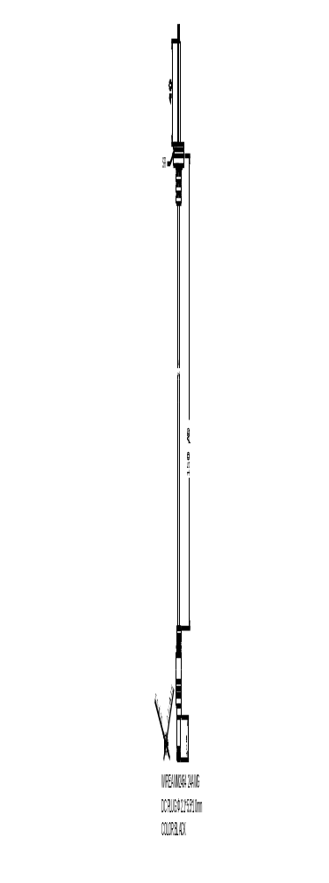

Production of appearance drawing(black):
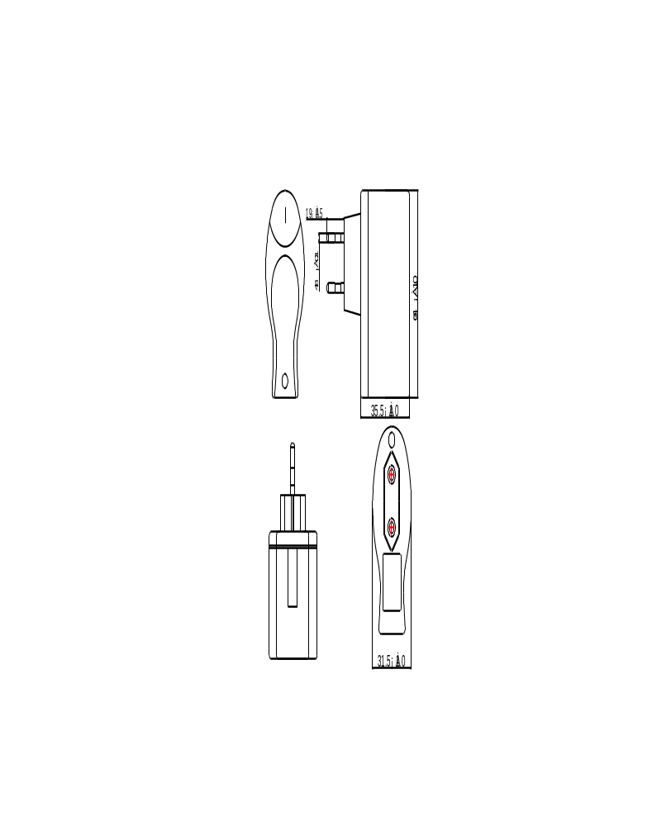

Label:
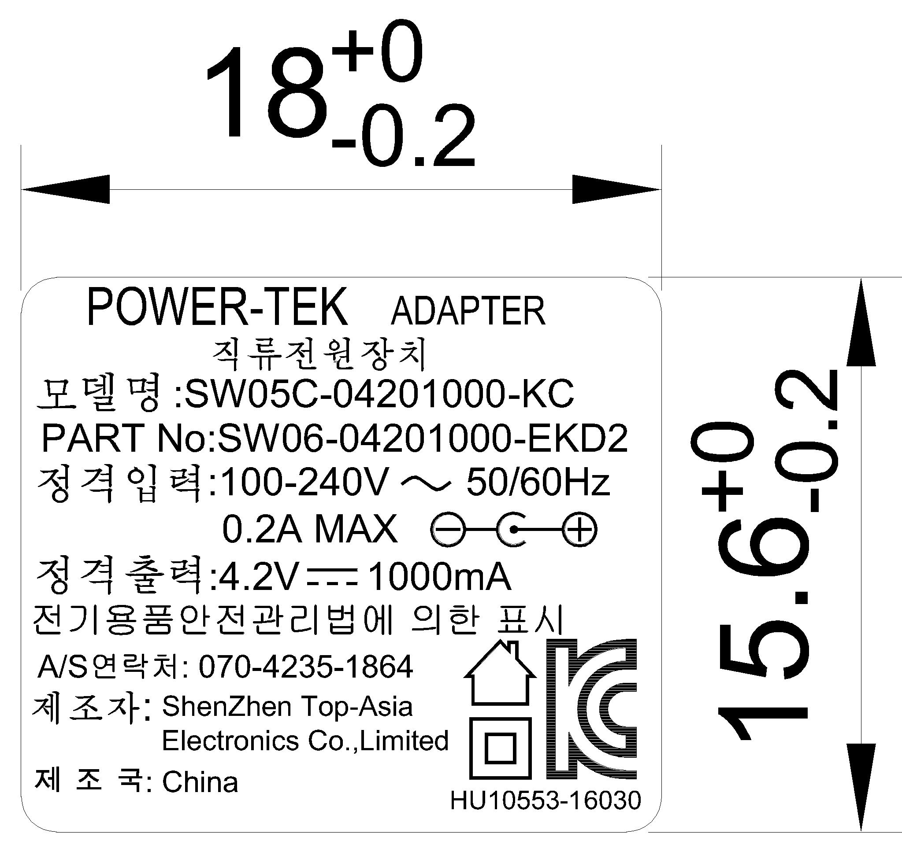

备注：
铭牌颜色：灰底黑字

9. PE BAG
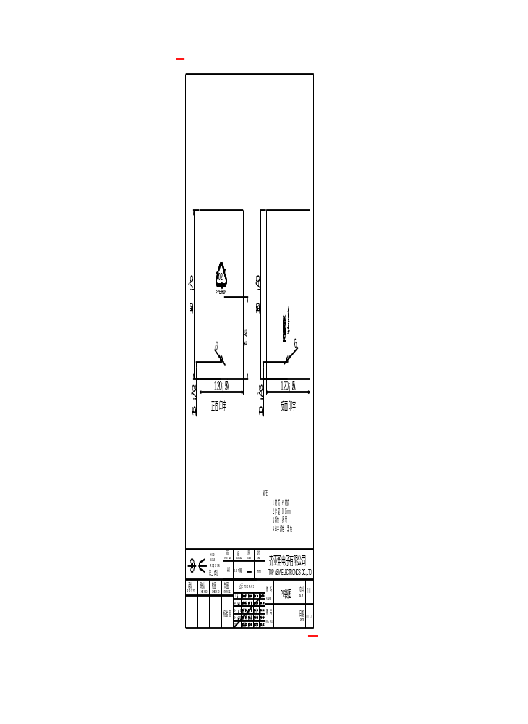

10. Packing


